DAY 10 assignment

/*1. Write a function to Calculate the total stock value for a given category:

(Stock value=ROUND(SUM(unit_price * units_in_stock)::DECIMAL, 2)

Return data type is DECIMAL(10,2) */

CREATE OR REPLACE FUNCTION get_total_cost(p_product_id INT)

RETURNS DECIMAL(10,2)

LANGUAGE plpgsql

AS $$

DECLARE

v_stock_value DECIMAL(10,2);

BEGIN

SELECT

ROUND(SUM(unit_price * units_in_stock)::DECIMAL, 2)

INTO v_stock_value

FROM products p

WHERE p.Product_id = p_product_id ;

RETURN v_stock_value;

END;

$$;

---call functions

SELECT get_total_cost (10);

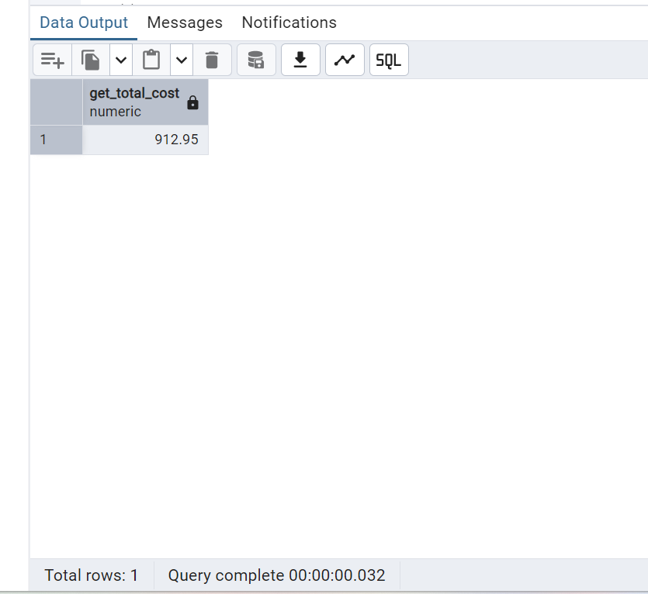

----2.Try writing a cursor query which I executed in the training

Create OR REPLACE procedure update_price_with_curson()

LANGUAGE plpgsql

AS $$

DECLARE

product_cursor CURSOR FOR

SELECT product_id, product_name,unit_price, units_in_stock

FROM products

WHERE discontinued =0;

product_record RECORD;

v_new_price Decimal(10,2);

BEGIN

OPEN product_cursor;

LOOP

--fetch the next row

FETCH product_cursor INTO product_record;

---exit when no more rows to fetch

EXIT WHEN NOT FOUND;

---calculate new unit price

IF product_record.units_in_stock < 10 THEN

v_new_price := product_record.unit_price * 1.1; --10% increase

ELSE

v_new_price := product_record.unit_price * 0.95 ;---5% Decrese

END IF;

---update product

UPDATE products

SET unit_price = ROUND(v_new_price, 2)

WHERE product_id = product_record.product_ID;

RAISE NOTICE 'Updated % price from % to % ',

product_record.product_name,

product_record.unit_price,

v_new_price;

END LOOP;

CLOSE product_cursor;

END;

$$;

--To execute

CALL update_price_with_curson();

